Participation in Meetings Objective

Started a question tracker – this is a document which stores all questions I have and the answers to them. Split into subject matter as well to make things easier to find in the long run. A snapshot is shown below.

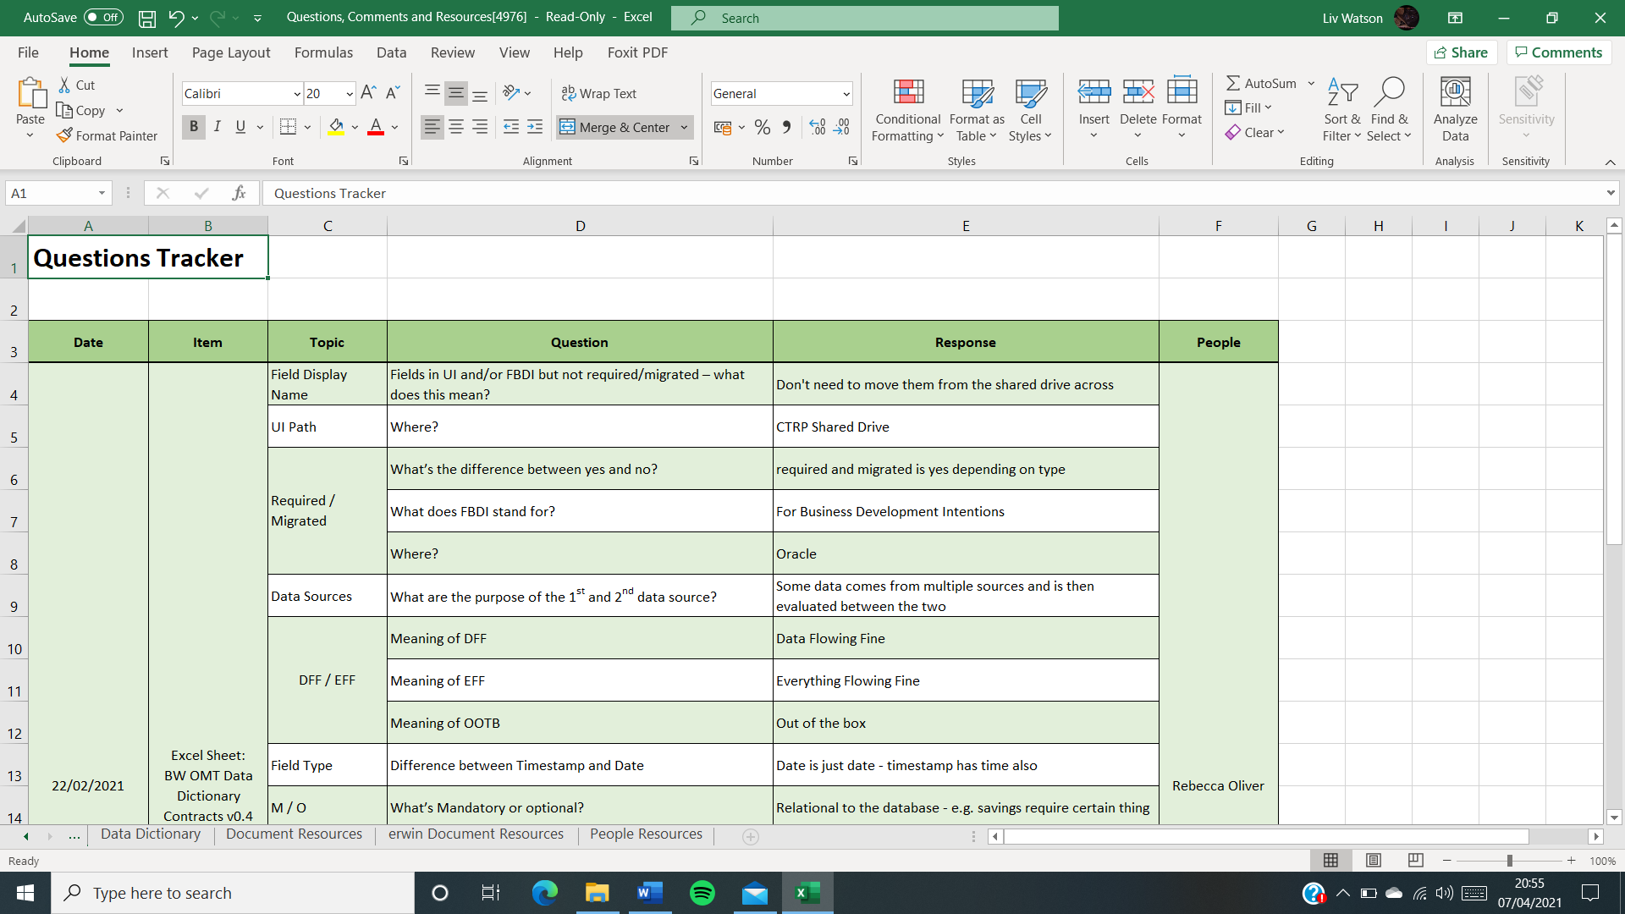

This tracker allows me write down my questions in advance of any meeting and pull them out as and when required. It’s also helped to cut down my note taking as a lot of the work is done in advance. This tracker also helped with meetings I was given little notice for as they were there, and I had typically researched the subject matter at an earlier date.

Took less detailed notes (also shared the responsibility with others). This was easier to accomplish because the meetings I was attending I felt more in the know how about the subject matter at hand. I also started to create an agenda for myself before hand which allowed me to just fill in the blanks in a sense for the meetings. I found these notes to be just as useful as the more detailed type. It also allowed me more thinking time because of me listening more carefully to the conversation at hand to get the more certain points, instead of just writing everything I head down and reviewing later.

An example meeting minutes for an hour call – and the notes taken here are just as usefully as a transcript of the entire conversation in my opinion.

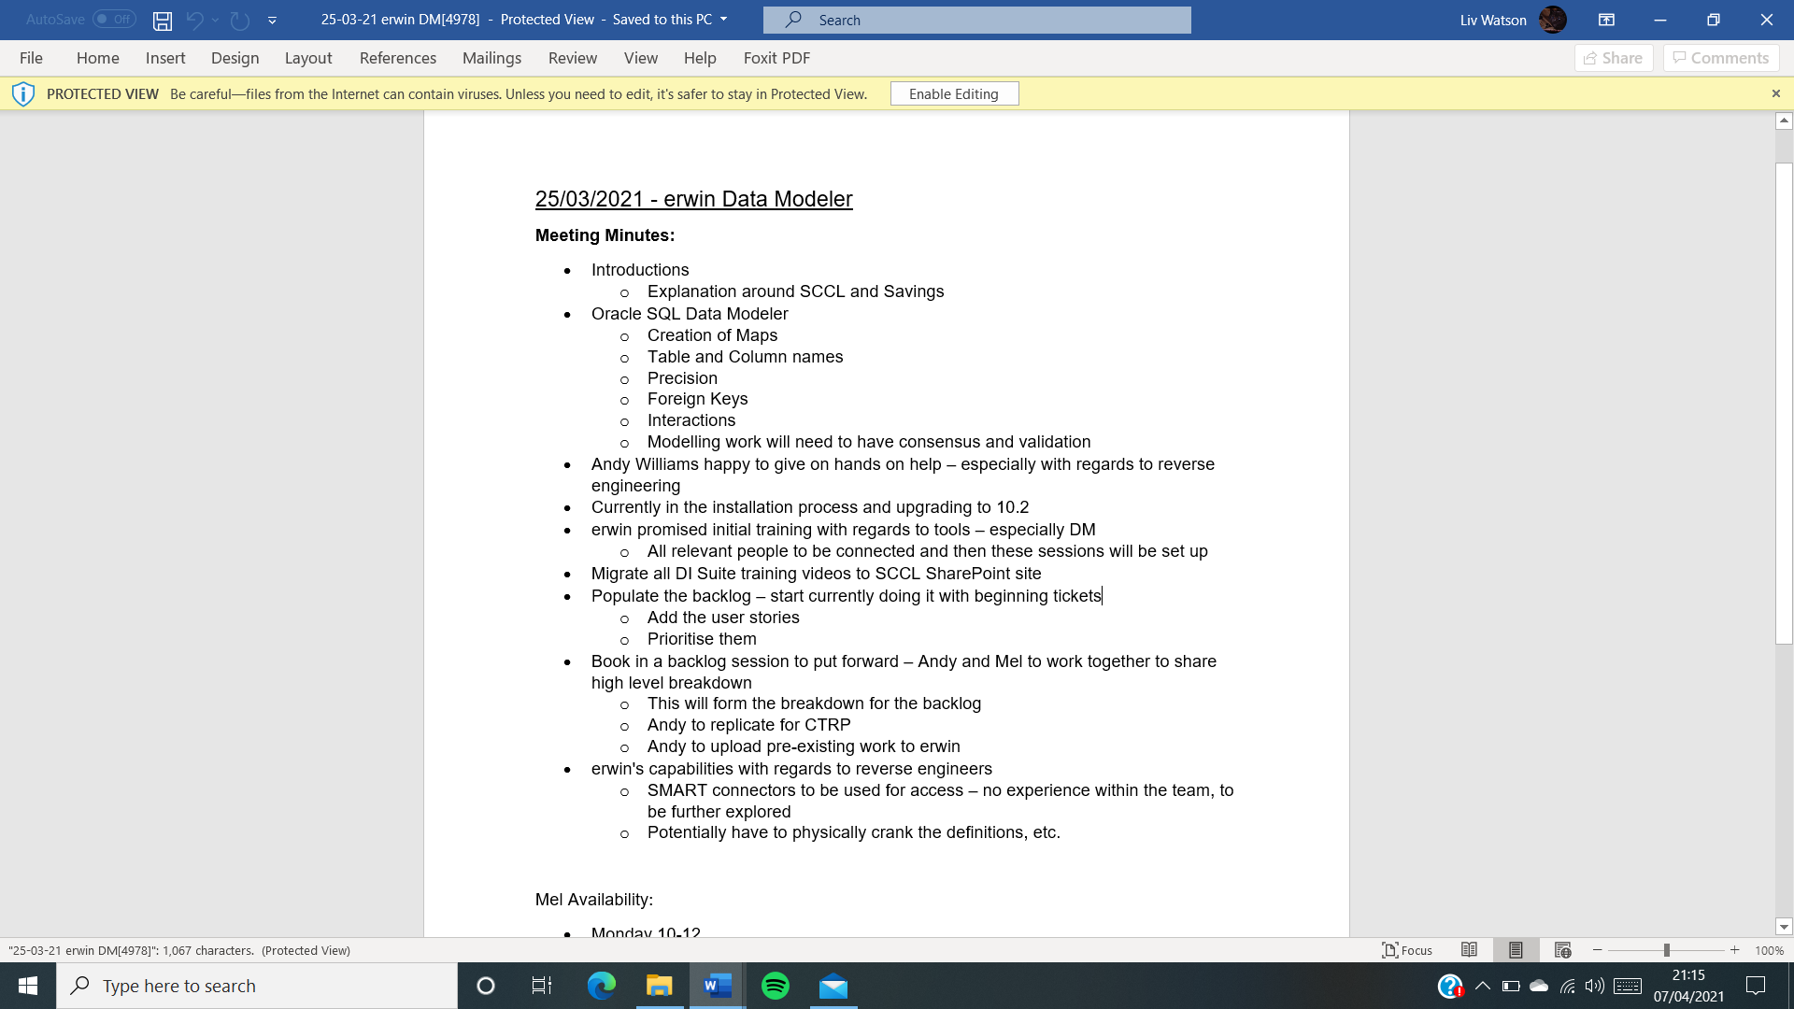

78 Meetings in total attended and 103 relevant questions asked. I determine about 24 of them to be impactful questions. What I determine to be impactful questions are questions that help the conversation to flow and explore a new area/route that wasn’t necessarily thought of before.

In the erwin project I had a couple of good questions around SMART connectors and their use/benefits for SCCL. Also really helped to lead the conversation in the app development meetings – next steps for the project, where to go tech wise from here, tech requirements and what the tech team need from the business team. Furthermore, other weekly meetings I started to ask questions around what people were doing – learned new facts and gained a few useful connections for my role – Lauren Newton offered to lend a hand with regards to somethings I’ve been stuck on. Have also been leading a charity project which allowed me to explore some leadership skills and really take charge of the conversation. Weekly tech team meetings also saw me bringing my ideas to them and getting more involved in the discussion – for example digital art.